**MANANSALA, JOHN PAUL U. IAS 101**

**BSCS 3A MR. CHRISTIAN TORRES**

**Midterm Activity 1**

**Instructions:** Infographic on Cybersecurity Awareness Objective: To enhance understanding of key cybersecurity concepts and promote awareness through the creation of a visually engaging and informative infographic.

Topic selection or choose one specific aspect of Cyber Security Awareness.

**“SAFE SOCIAL MEDIA USAGE”**

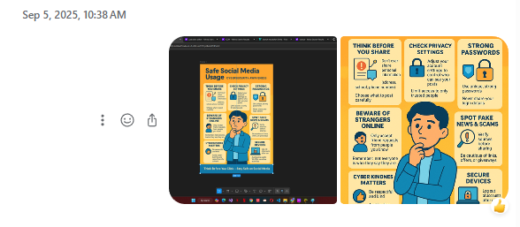

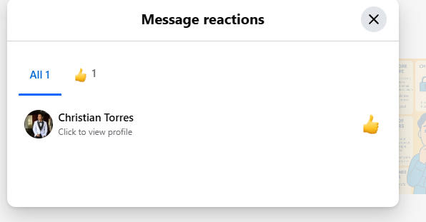

1 React = 2 pts

1 Share = 3 pts

**Computations:**

**Total Reacts – 88 x 2 =176**

**Total Shares – 275 x 3 = 825**

**Total Points = 1,001**

**Posting**

**Approved**